Data procedures for Movies.csv:

1. Data was collected and given by UpGrad (E-learning platform) while undertaking module 7 of ‘Business Analytics’ course.
2. Spreadsheet name “Module 7.2 Movies.csv”
3. Received on 27th Aug,2020.

Cleaning:

1. 45 Duplicate rows removed, 4999 unique rows found.
2. Found 57 blanks under column ‘language’. Since, English has 93.50% of preference among all other languages, the blank columns are filled with English.

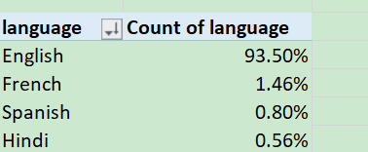

1. To replace, Ctrl+H. Find blank, replace: English.